# FTP and VSFTP

FTP – File Transfer Protocol. Used to transfer files from one machine to another. Of course, we’ve seen the usage of the command **SCP** that we can use to transfer files over a private network. FTP is different, as we can narrow down the access for users (ie: what resources they can access, their privileges, etc).

Users can log in via ftp accounts, or we can enable anonymous connections.

* To begin, we need to install a program called vsftpd: **sudo apt install vsftpd**

Note that VSFTPD is running immediately after installation.

Next open a port in the firewall for FTP: **sudo firewall-cmd –permanent –zone=public –add-service=ftp**

* Install the firewall daemon: **sudo apt install firewalld**

* **sudo firewall-cmd - -permanent –zone=public –add-service=ftp**



* **sudo firewall-cmd –reload**



Let’s create a user called ftp-guy with a password “ftp”

Using the command **ftp<hostname/ipaddress>** we invoke the ftp program and connect to the desired server. The hostname must be in the /etc/hosts file or have dns entry on a reachable dns server.

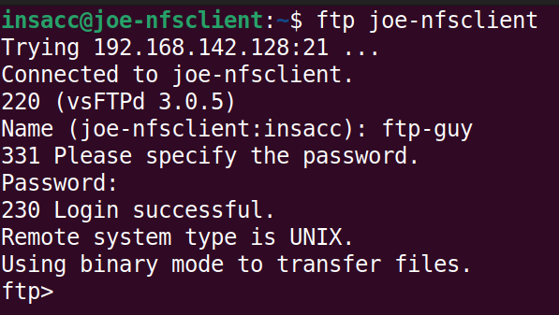

Note that it asked for a username and password, use ftp-guy / ftp

Some things we can do:

1. Using the command **ls** will display the file listing for our remote directory. In this case, when we’ve logged with account ftp-guy, it’s opened up his home directory (/home/ftp-guy)

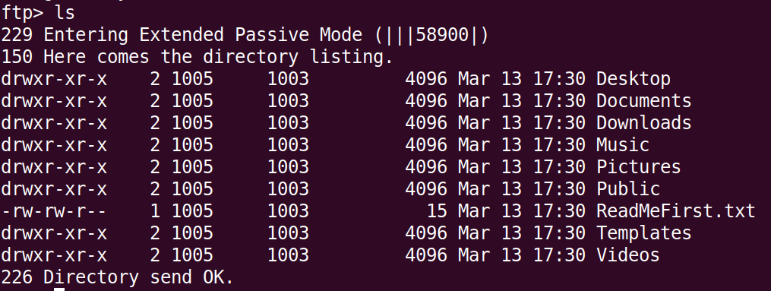

1. If we use a command with “!” notation, that will run the command locally (I’m currently logged into my Linux VM as **insacc**, so the directory I was in before I connected will be displayed instead).

1. We can type “?” to get a list of command that are available to us.

1. If we want to change our directory (locally), we can use the command “**lcd**” – using !cd does not work! This allows us to change our local directory (which is useful if we don’t want to disconnect from the ftp server in order to change our working directory locally, ie: when transferring files)

1. The “get” command will receive a file from the remote ftp server and copy it locally (download).

Note the syntax for the **get** command, if you don’t want to change the name, the second name can be omitted.

1. The “put” command will transfer a file from the local system to the remote host (upload).

Notice when we use the “put” command, we get an error called “550 Permission denied”

***By default, vsftpd is **not** enabled to accept file transfers, so we’ll need to go into the configuration file and make the necessary changes. We can also edit some other information there as well.

1. The configuration file is located: **/etc/vsftpd.conf** (perhaps open another terminal for this step)

Looking at this file, it will have a lot of configuration directives, but most of them will be commented out via #.



Removing the comment from the line that starts with “#write_enabled” will allow users with sufficient permissions to write files from their local system to the remote system (ie, the **put** command)

Removing the comment from the line that starts with “#ftpd_banner” will allow us to put a custom message to be displayed to the user when they connect.

Next run: **sudo systemctl restsart vsftpd**

1. Try the put command again:

1. Logging out and back in, we see the new banner message as well.

1. Logging on as ftp-guy we can see the file has successfully been transferred:

**Exercise 1:**

1. Install vsftpd in your VM.
2. Create a user called “ftp-user” with password “ftp”
3. Modify /etc/vsftpd.conf file to allow users to upload files, and change your banner
4. Record your ip address (run hostname -I) to find this.
5. Pass it along to another person in class as well as receive their ip address.
6. Add a record in your /etc/hosts file for your partner’s ip address and choose a friendly name.
7. Connect to your partner’s ftp server and put a file. Have your partner confirm it’s in ftp-guy’s home directory.

## Restricting Which Users Can log in

Let’s restrict who can log in – maybe we don’t want our main user to login

To do this, we’ll need to create additional directives in our **vsftpd.conf** file in the /etc directory. The following directives will ban some users from logging in:

* userlist_enable=YES
* userlist_deny=YES 🡨 anyone on this list will be denied “blacklist”
* userlist_file=/etc/vsftpd/denied_user_list

We’ll also need to create the /etc/vsftpd directory as well as the file denied_user_list and then add poor ftp-guy ☹

Let’s **sudo systemctl restart vsftpd** and try to connect to the ftp server with user ftp-guy:

So we’ve seen a list provided of users who are denied access. Let’s flip that on it’s head to provide a list of users who can log in. (Whitelist – this much more secure!)

We’ll need to edit our vsftpd.conf file again and change/add some directives:

* keep the directive userlist_enable=YES
* change the deny directive:
  + userlist_deny=NO
* change the userlist file path:
  + userlist_file=/etc/vsftpd/allowed_user_list

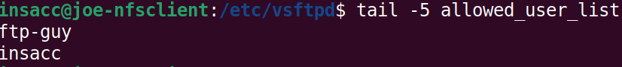

Now we can log in only as the users in the allowed_user_list, other users are denied:

**Exercise 2**

1. Create a user called “partner-user” with password “ftp”
2. Modify /etc/vsftpd.conf file to allow users to transfer files, and change your banner
3. Modify /etc/vsftpd.conf file to allow for a user list that contains a list of users allowed to access your ftp.
   1. Add ftp-guy and partner-user to that list
4. Record your ip address (run ip addr) to find this.
5. Pass it along to another person in class as well as receive their ip address.
6. Add a record in your /etc/hosts file for your partner’s ip address and choose a friendly name.
7. Connect to your partner’s ftp server and put a file. Have your partner confirm it’s in ftp-guy’s home directory.